“Data Visualization : Empowering Business with Effective Insights Using Power BI “
Monthly Revenue Trend (CEO)
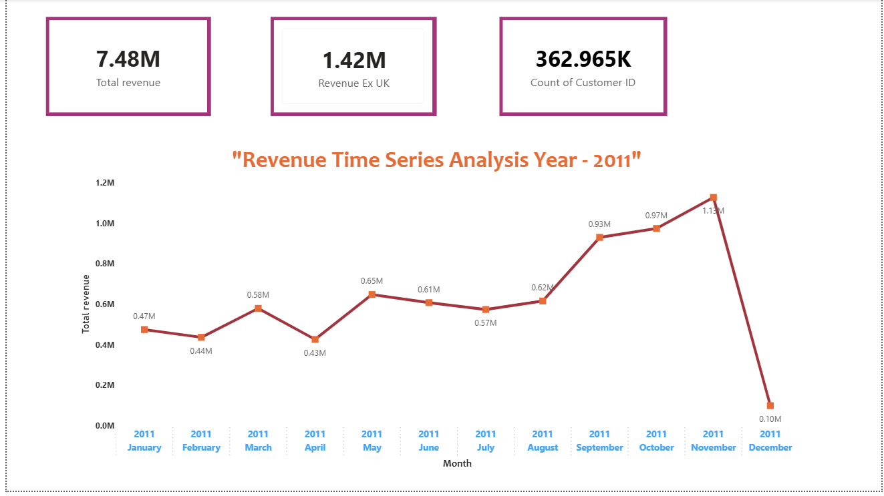
TOP 10 Countries Excluding UK (CMO)
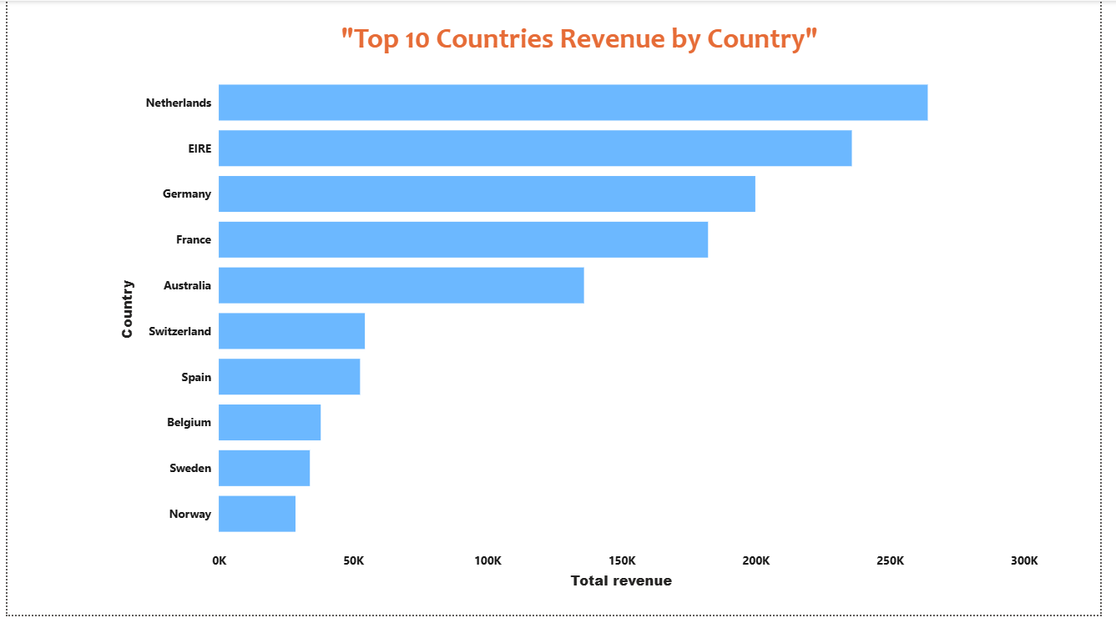
Top 10 Revenue Generating Customers (CMO)
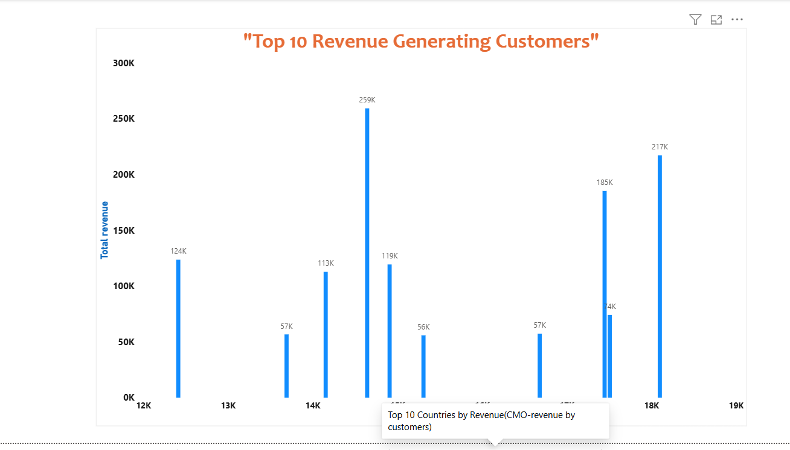

Global Demand View (CEO)
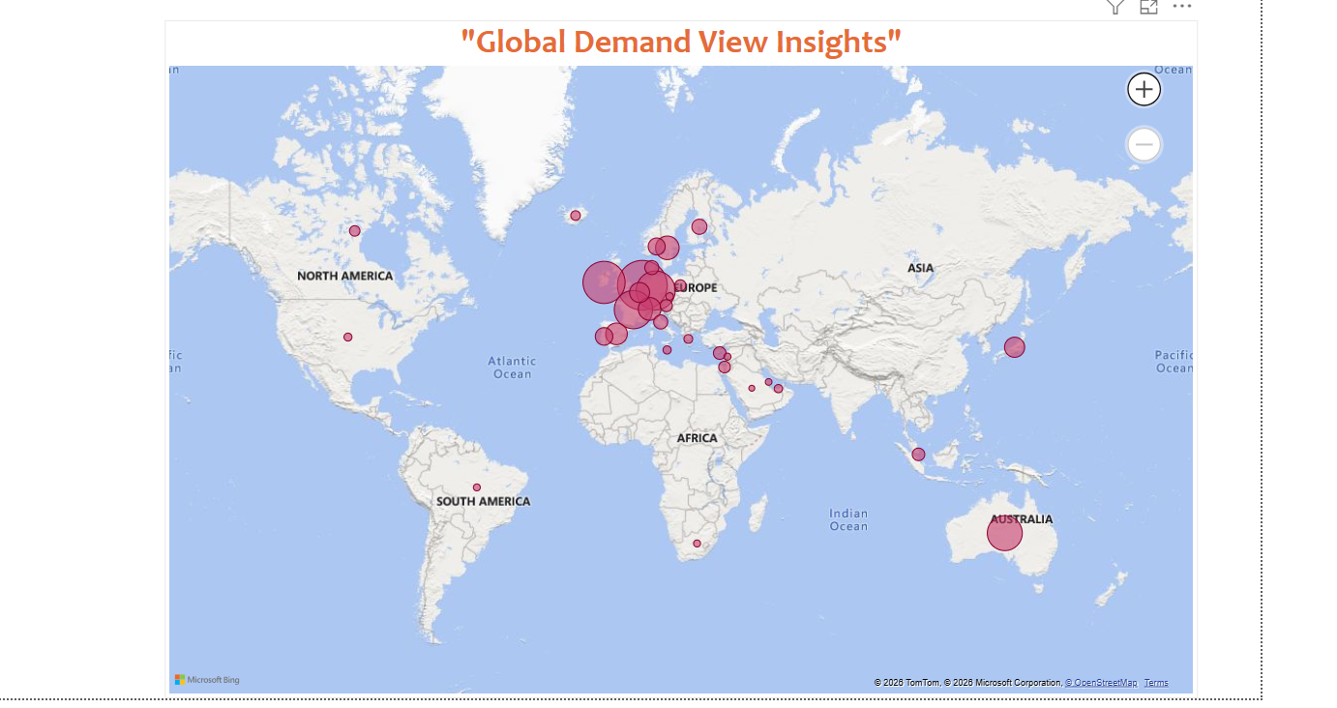

Quantity vs Revenue by Product (CEO)
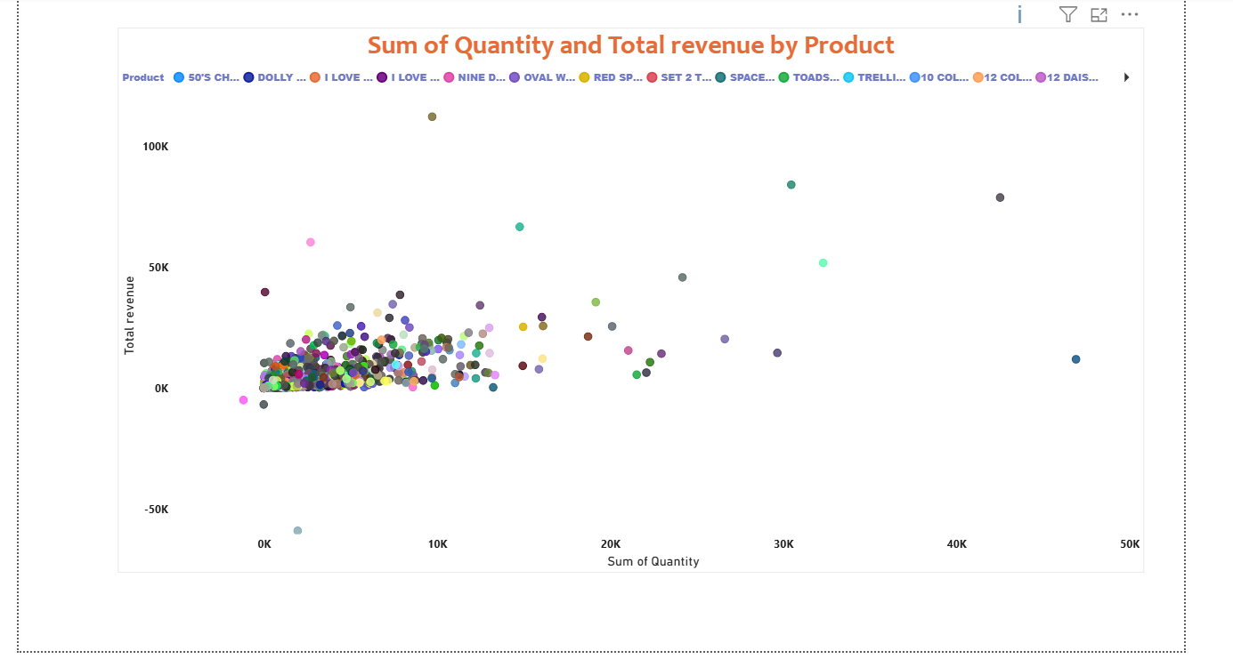
Key Takeaways:
- The time series analysis revenue peaked sharply in November 2011 at over $1.0M, confirming a strong seasonal surge in Q4.
December shows a sudden drop, likely due to incomplete data rather than an actual business decline.
- The top Country analysis showed Netherlands leads international revenue at ~$300K, nearly double second place EIRE(Ireland).
Western Europe dominates the top 10, with Spain, Sweden, and Norway showing untapped growth potential.
- The customer analysis top customers alone generated ~$259K, significantly ahead of all others in the top 10.
Revenue is heavily concentrated in a few high-value accounts making retention if these customers a business priority.
- The global demand view is concentrated in Western Europe, with Australia the only notable market outside Europe.
North America, Asia, and South America show minimal presence representing clear international expansion opportunities.
- The Quantity vs Revenue products cluster in low quantity and low revenue, revealing a long tail of slow-moving items. Few outliers drive high volume or high revenue these are the priority products worth focusing on for growth.

